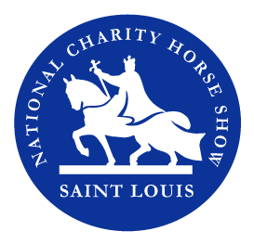Prize List Advertising Form

Company OR Personal Name

Contact person (if different from above)

stlhorseshow.com Address City/State/Zip

Phone # Fax # E-mail _

Name as it should appear on printed materials:

Artwork and program advertising must be submitted no later than May 20.
Submit as PDFs to: lisamills211@gmail.com

All advertising is black & white.

_____$250 - Full Page (5.5" x .5") $125 - Half Page (4.25" x 5.5")

Method of payment - (Gifts are tax deductible according to the amount allowed by law)

Our check is enclosed made payable to: St Louis National Charity Horse Show

Mail check to: 288 Howell Road, Defiance, MO 63341

Credit Card: _____MC _____Visa

Credit Card#

Exp. Date: Security Code

Name as it appears on the card:

Signature:

E-mail: stlnationalcharityhs@gmail.com Website: www.stlhorseshow.com

For Horse Show Use Only

Donation Solicited By: Date:

Amount Date Received Date Deposited

Acknowledged

