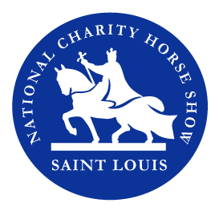
Show Program Advertising Form

Company OR Personal Name

Contact person (if different from above)

Stlhorseshow.com Address City State Zip

Phone # Fax # E-mail

Artwork and four-color program advertising must be submitted no later than Aug 18, 2019.
Submit ads as PDFs or JPEGS to: lisamills211@gmail.com

$500 – Back Cover (8.5” x 11”) $150 – Half Page (8.5” x 5.5”)

$400 – Inside Front or Back Cover (8.5” x 11”)

$600 – Two Page Spread (11” x 17”)

$300 – Full Page (8.5” x 11”)

Method of payment – (Gifts are tax deductible according to the amount allowed by law)

_____A check is enclosed made payable to St Louis National Charity Horse Show

Please mail check to 288 Howell Road, Defiance, MO 63341

_____Credit card payment

Credit Card # ____

___MC ___Visa Exp. Date __________Security Code___________

Name as it appears on the card:

Signature:

Email form with credit card information to: eahazzard@hotmail.com

